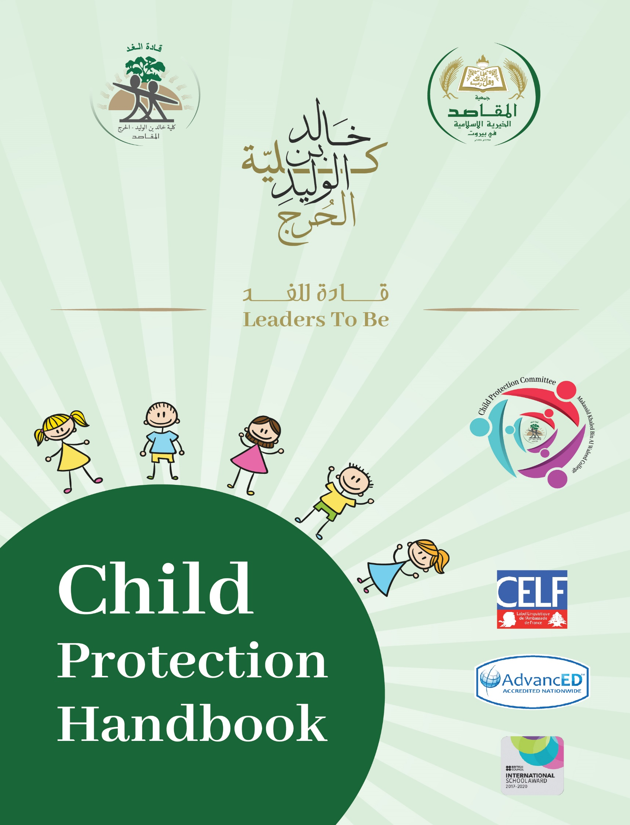
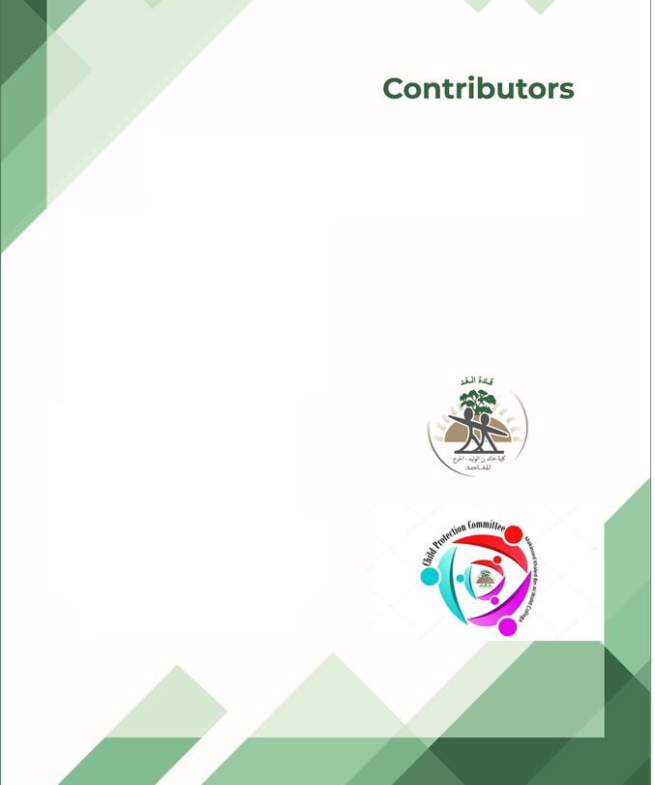
Hasnaa Mneimneh
Lara Jannoun
Rouba Habanjar
Lina Taha
Table of Content

Introduction……………………………………………………………………………..... Pg. 4
Child Protection Committee ………………………………………………………...…… Pg. 5
Members of the Committee Roles and Responsibilities ………………………………… Pg. 7
Child Protection Framework …………………………………………………………….. Pg. 9
Child Protection Policy …………………………………………………………………... Pg.10
Definition and Types of Child Abuse ……………………………………………………. Pg. 12
Code of Conduct …………………………………………………………………………. Pg. 19
Students’ Behavior Code …………………………………………………………………. Pg. 20
Effective Classroom Style ………………………………………………………………... Pg. 23
Classroom Management Tips ……………………………………………………………. Pg. 24
Cyber-Bullying Policy …………………………………………………………………….Pg. 26
Trip Safety Policy ………………………………………………………………………... Pg. 28
Playground Safety Policy ………………………………………………………………… Pg. 32
Bus Safety Policy ………………………………………………………………………… Pg. 35
Appendix …………………………………………………………………………………. Pg.36
Appendix 1: Recruitment Policy …………………………………………………………. Pg. 37
Appendix 2: Code of Conduct for Staff …………………………………………………...Pg. 39
Appendix 3: Code of Conduct for Preschool……………………………………………… Pg. 41
Appendix 4: Code of Conduct for Elementary …………………………………………… Pg. 42
Appendix 5: Code of Conduct for Middle and Secondary………………………………… Pg. 43
Appendix 6: Family Issues ………………………………………………………………..Pg. 44
Appendix 7: Students’ behavior Records…………………………………………………..Pg. 45
Appendix 8: Safety Inspection Checklist ………………………………………………….Pg. 46

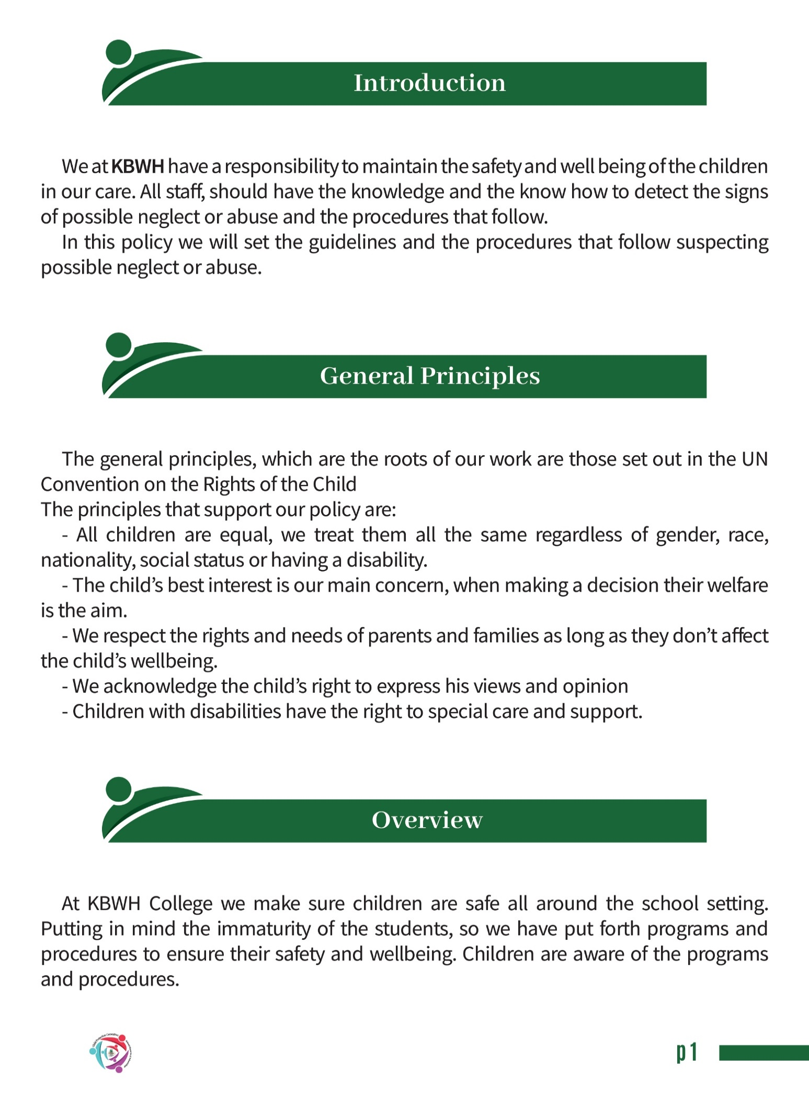

Child Protection Committee

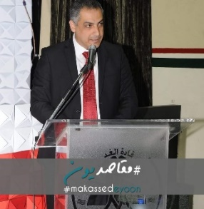
Mr. Amin Tawil Khaled Baghdadi

School Principal SchoolAdministrator

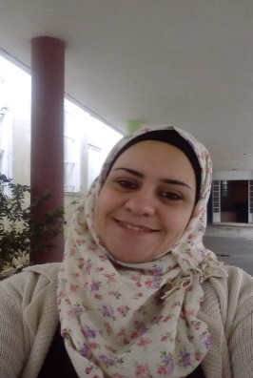
Safaa Itani Hasnaa Mneimneh

School Nurse School Counselor
(Middle & Secondary)

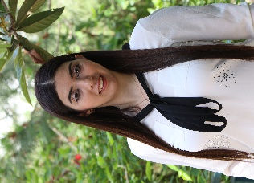

Hania Knio Lara Janoun

School Counselor
Preschool & Elementary Head of Preschool

Lina Taha Rola Alawyan

Head of Cycle Four Head of Cycle Three Secondary Intermediate

Rouba Habanjar Mariam Rabaa

Head of Cycle One Head of Cycle Two
Elementary Elementary

Laila Zaim Issam Matar

Supervisor Supervisor
Grade 9 Grade 10

Mariam Trabulsi Mohamad Itani

Supervisor Supervisor
Grade 11 Grade 6

Rouham Hamza Hiba Khanji

Supervisor Supervisor
Grade 1 Grade 5 & 4

May Moumneh Nancy Baydoun

Supervisor Supervisor
Grade 2 & 3 Preschool

Fatima Cherkawi Sawsan Sharief

Supervisor Supervisor
Preschool Grades 7 &8

Child Protection Team Members
-Roles and Responsibilities-

The School Safeguarding Team:
The following are members of the school’s Safeguarding Team: (here names should be listed for each position)
-Chair of the board
-Designated Governor for child protection
-Principal / Designated Teacher
-Deputy Designated Teachers

Roles and Responsibilities for the members of the team:
Chair of the board of Governors
*Ensuring that a Child Protection policy is in place,
*Ensuring that a Designated Governor for Child Protection is appointed,
*Ensuring that Governors receive relevant training in child protection and recruitment and selection.
Designated Governor for child protection:
Gives advice on child protection matters. The designated governor is also responsible for the recruitment, selection, and vetting of staff and the role of the designated teacher.
Principal:
*Enabling the board of governors fulfil their child protection duties
*Maintaining and securely storing the school record of child abuse
*Appointing suitable staff to posts (teaching and non-teaching)
*Appointing suitable teaching staff for the roles of Designated and Deputy Teacher for Child Protection
*Ensuring that parents and students receive a copy of the Child Protection Policy every 2 years
-Designated and Deputy Designated Teacher for Child Protection

The Designated teacher and the Deputy Designated Teacher who is appointed to support the Designated Teacher, are both members of the safeguarding team. The role of the Designated Teacher includes:
*Providing training for the whole staff in the school about Child Protection (once every year)
*Responsible for development and annual review of the protection policy
*Point of contact for staff and parents
*Keeping records secure
*Giving an annual report to the Governors on child protection activity.
The Deputy Designated Teacher will deputies for them in their absence.

Child Protection Framework
Students are admitted to the school’s playgrounds starting from 7 o’clock until the bell rings at 7:25 and then after line up they go to their classes, during this time they are supervised and accompanied by administrative assistants and teachers the whole time. After the bell rings all gates are closed except the gate leading to the administration office for organizational purposes. All visitors must have clearance before entering the school and get an ID with a number on it.
Trusted security personal are placed at each gate to ensure the safety of the students and to give visitors clearance.
Students are not allowed to leave school premises without a permission and a valid reason. Younger students must be accompanied by their parents or guardians; older students may leave alone if parents agree.
Parents are encouraged to pick up students in a safe matter. No cars are allowed in the school premises only school buses are allowed to enter to collect the students. Cycle one students are placed in a gated playground and parents are informed to pick them up from there to ensure their safety.
Students stay after school only 2 days per week for Clubs and Sporting activities if they have a written permission from parents.
Our school is mindful of the particular needs of some children that is why the school is equipped to help them move safely all over the school with minimum discomfort.
All staff teaching and non-teaching get their positions based on a recruitment policy and sign a code of conduct. (See Appendix 1 and 2)
They all receive training in Child Protection and they are able to detect signs and symptoms of neglect and abuse and all the procedures that follow.
The school seeks parents’ consent before using any child photo for educational/PR purposes.
The school is obliged to give out information about the child to any person with parental responsibility in case of separation or divorce. (See Appendix 6)

Child Protection Policy

Introduction
Based on the international child protection law and the Lebanese ministry of education, school leaders are responsible to protect children and establish child protection safeguards; therefore, everyone at school has a responsibility to support and protect children. All members at school should consider the objectives behind child protection policy, which in themselves affect our ability to protect them.
These are,
• Understanding the way we see childhood, children, their experiences and their rights,
• Identifying the different types of child abuse and the effects these have on children's lives,
• Recognizing the signs and symptoms, risk factors and vulnerabilities, which may indicate a child in your class is suffering abuse,
• Responding appropriately when you think, or you are told, that a child in your class is being abused,
• Identifying the key steps that you can take to protect children against actual or cyberbullying.

Rationale
Teachers are an integral part of a child's life and so protecting them and their rights should be at the heart of all their work. Being aware of children's rights to live free from abuse as well as knowledge of their assumptions and views of childhood and children is the foundation stone of child protection.
Our main aim at KBWH is the child and his welfare that is why we have set a “Child Protection Policy” that shows the different kinds of child abuse and describes the procedures that follows when faced with any case of abuse or neglect.

We have also written a “Code of Conduct” that clarifies the school’s mission, values and principles, linking them with standards of professional conduct. Our code articulates the values the school wishes to foster in staff teaching and non-teaching and, in doing so, defines desired behavior.

The Four Guiding Principles for Children's Rights
Children need education, love, warmth, food, health, play, friends, safety etc…, and their basic needs are their rights. We all have human rights but children's rights need to be extra protected. This is because children are less powerful, have less political or social voice, yet they are seldom given a 'voice' in services and are vulnerable to ill-treatment by adults.
The four guiding principles of children’s rights are as follows:
- Non-discrimination: The Convention applies to ALL children regardless of race, religion, culture, ability etc. No child should be treated unfairly on any basis.
- Best interests of the child: The best interests of children must be a primary
concern in making decisions that affect them. All adults should do what is best for
children.
- Right to life, survival and development: Children have the right to live and
develop healthily.
- Respect for the views of the child: Children have the right to have their
opinion counted.
Actions:
Our main responsibilities in the area of Child Protection are prevention, recognition, response, referral and confidentiality/record keeping.
-Prevention: The school provides a safe and supportive environment for children and young people who have been abused or might be in the future. Students are encouraged to discuss concerns they might have on any issue with their advocate teacher or any other member of the committee to whom they can relate easily.
-Recognition: The staff teaching and non-teaching possess the know how to recognize signs of abuse or neglect and the steps that follow.
-Response: Trained personal are the only party allowed to talk to abused or suspected to be abused children.

-Referral: Any disclosures or concerns of a Child Protection nature must be referred immediately to the chair of the Committee.

-Confidentiality/ Record keeping: In keeping with the principle of confidentiality, information sharing regarding abuse, neglect, or any other crucial information.
Also, all records of students misbehaving must be kept at the supervisor office with confidential notes to be shared with the counselors. (See Appendix 7)
What is Child Abuse?
"Child abuse and neglect, sometimes referred to as child maltreatment, is defined in the World Report on Violence and Health (2002) as all forms of physical and/or
emotional ill-treatment, sexual abuse, neglect or negligent treatment or commercial
or other exploitation resulting in actual or potential harm to the child's health,
survival, development or dignity in the context of a relationship of responsibility, trust or power" WHO, 1999 & 2002. In simple terms child abuse is when an adult harms a child or young person under the age of 18.
There are four main forms of child abuse internationally recognized: Physical,
sexual, emotional abuse and neglect.
The Four Main Forms of Child Abuse
1) Physical Abuse: this is when a child is hurt or injured physically. It includes hitting, kicking, punching, biting, burning, shaking, drowning, smothering and giving drugs or alcohol. It also includes making children adopt the same position for a long time as a punishment (such as standing with arms over head).
2) Sexual Abuse: this is when a child is used sexually. It includes kissing, touching genitals or breasts, vaginal or anal intercourse, oral sex, and encouraging to look at pornography.
3) Emotional Abuse: this is when children are denied love or affection. It includes threats, humiliation, sarcasm, degrading punishments, undermining confidence.
4) Neglect: This is when children's basic needs are not met by their parents, where they have the means and access to services to do so. They are denied love, food, warmth, safety, education or medical attention.
These four forms of abuse have been categorized and identified by extensive research and reports and are commonly recognized as the main forms. International research such as the World Report on Violence and Health (2002) and the World Report on Violence Against Children (2006), and work from development organizations such as UNICEF all detail more information on this area. There are other manifestations of child abuse such as exploitation, racism or bullying.
Professionals often identify child abuse by recognizing signs and symptoms of the different forms of abuse. All children and all situations are different but these lists of signs symptoms give us a guide and increase our awareness:
Indicators of Physical Abuse  - Frequent injuries or unexplained bruises, fractures, welts, burns or cuts  (beyond normal childhood bumps and falls).  - Depression and anxiety and/or aggression and violence  - Problems with relationships and  socializing.  - Distant and withdrawn.  - Wears inappropriate clothing to cover up injuries, such as a coat on warm days.  - Running away from home or fear of parents being approached.  - Long-term effects include post-traumatic stress disorder and other mental health  issues. | Indicators of Sexual Abuse  - Suddenly behaving differently  - Aggressive behavior, risk taking and missing school or running away  - Sleep problems and bed-wetting or soiling  - Negative thoughts, not looking after themselves  - Displaying sexually in appropriate behavior
Indicators of Emotional Abuse  - Possible delayed physical, emotional and mental development.  - being unable to play or socialize well with others  - Self-harm  - Sudden speech disorders  - Neurotic behavior such as hair twisting or rocking  - fearful of making mistakes | Indicators of Neglect  This is the hardest form of abuse to recognize. It will be particularly difficult in areas with poor resources where a lot of children lack basic requirements such as food or medicine. Possible indicators includes:  - Delayed development  - Poor hygiene, unwashed clothes or inadequate clothes, untreated medical conditions (where most other children have these things).  - Being hungry or tired all the time.  - Missing school or difficulties with school work  - Withdrawn and difficulty making friends and/or anti-social behavior  - Neglect can lead to serious and long- term damage.

If you see a warning sign it does not automatically mean a child is being abused, but it is important to look into your concern. Often a sudden change in behavior is a good indicator. Because teachers know children well so they are in a very good position to notice any concerns or unexplained changes in behavior.
Some children will be more vulnerable to abuse, either because of individual characteristics or the situation they are in. Some vulnerability factors include age, disability, low self-esteem, previous experience of abuse, experience of loss or bereavement, difficulties in the family home, poverty or being separated from family (for example as a result of natural disaster or conflict).
Other Forms of Abuse:
As mentioned before, child abuse is commonly spilt into four main categories. However, there are some particular manifestations of child abuse to be aware of. Specifically, Exploitation and Bullying are useful for teachers to know about.
Exploitation:
Child exploitation refers to the use of children for someone else's advantage, gratification or profit often resulting in unjust, cruel and harmful treatment of the child.
These activities are to the detriment of the child's physical or mental health, education, moral or social-economic development. It covers situations of manipulation, misuse, abuse, victimization, oppression or ill-treatment.
Bullying:
Bullying is an aggressive behavior that is intentional and that involves an imbalance of power or strength. It occurs across all geographic, racial and socio-economic boundaries. Bullying occurs when a student is subjected to negative behavior, repeated over a period of time, by another student or group of students.
Barriers to reporting abuse:
We might assume that children would just tell someone if they are being abused. However, children's experience of abuse will be complex and it can be very difficult to tell anyone.
Children:
- fear of not being believed,
- fear it will get worse if they tell,
- they have been threatened by the perpetrator,
- they don't know whom to tell, and
- they think it's normal to be treated like this.
Adults:
- they don't believe the child,
- their suspicions aren't confirmed and they don't want to get someone in trouble
for no reason,
- the child is a trouble maker so probably lying,
- they don't know who to tell or how to tell,
- they don't want to get involved,
- they have experienced abuse themselves, and
- they are scared they will make the situation worse for the child.
Part of protecting children at KBWH is creating an environment where child are safe, respected and listened to. Putting safeguards and advocates in place will help to remove barriers or will at least it will lower the barriers, provide bridges and shortcuts to a safe place where children are listened to and supported. Teachers must remember that they are not alone in dealing with any disclosure. Child Protection Team and the counselors will respond and work with children.

Procedures to Respond to Child Abuse
The school is responsible for keeping children safe from harm and abuse. KBWH has a safe learning environment, and work hard to identify pupils who are suffering or at risk of harm and take suitable action.
Response to disclosures or suspicions of child abuse.
How to respond if anyone at school (Teachers, administrators….) have concerns about a child discloses abuse? They will take suitable action based on procedures set out by Child Protection Team, letting the authorities know where it is required. Once the authorities are told, they will decide what to do.
Disclosures:
- explain to the child that he/she has to talk to the child protection team to see what can be done,
- explain that they will respect confidentiality and only talk to people who need to know,
- Act immediately and report to the child protection team. Any delay could leave a child in danger,
- Keep records of all conversations and actions taken, and
- Be transparent with the child so they are involved at each stage.

Responding Steps
- Data Collection and documentation
When the child protection team receives information about a disclosure, the team must record and assess the available information. At this stage, the main aim is to identify the risk level without compromising the safety and wellbeing of the child. The incident should be described to the authority of the child protection team with the necessary details and the information about any child remains confidential
Once sufficient information is collected, the child protection team will assess the severity of the case to determine the kind and the level of the risk the child is facing.
- Action Plan
Once all information is collected, the child protection team (counselor, nurse, and principals, supervisors) must discuss the best course of action. After consultation, possible responses may include one or more of the following:
  - Developing an internal action plan and recommendations to teachers in the school with the child protection team, especially the counselors, and monitoring the child.
  - Meeting with parent(s) to discuss concerns.
  - Referring the student or family to psychologists outside of school.
3. Confidentiality
All information relating to child abuse shared by students should be treated as confidential and, therefore, should not be discussed outside of the context of the reporting procedure. The child protection team must not share subsequent details about the child with the community member but rather, generally, reassure them that the child is being followed up on. In all situations, teachers will be provided with advice and guidance on how to deal with the child.
Procedures to Prevent Child Abuse
- School provides parents, staff and students with a common definition of child abuse (physical, neglect, sexual and emotional),
- Staff and teachers Code of Conduct to give clear expectations and boundaries,
- Students code of conduct to give clear expectations from students, and
- School leadership designs and implements procedures to ensure the safe recruitment and selection of staff.

Child Protection Code of Conduct
A code of conduct is set to be the guide for a wise conduct by the staff toward the students.
-Private Meetings with students:
As much as possible private individual meetings with students should be held in a room with a visual access or an open door.
The staff should always inform other adults about a meeting taking place by using certain indicators but not a sign banning entry.
If possible another student or an adult should attend the meeting.
-Physical Contact:
Staff are advised not to make unnecessary physical contact with their students, but staff should not feel inhibited from providing reassurance especially to younger children that might include physical comforting.
It is also preferred that administrating first aid to a student by any trained staff member should be supervised by another staff member but that doesn’t mean that no first aid should be provided if no other staff member is observing.
Staff members who supervise students in activities outside the school should be more careful and vigilant because the students will be in circumstances different from the normal school environment.
Physical punishment is illegal by all means.
What is code of conduct?
It is a set of rules outlining the social norms, rules and responsibilities of, and or proper practices for, all individual working or volunteering at our school.
All individuals should read and sign the conduct before starting active duty.
(See Appendix 2)

-Teaching Materials:
Teachers should avoid teaching materials that might be misinterpreted or unsuitable and have a sensitive nature. If in doubt, the teacher should consult the principal.
-Relationship and Attitudes: All staff must make sure that any relation with any student is appropriate to age, maturity, and sex of the student. They also must pay attention to everything said and done especially when dealing with adolescent boys and girls.
Students’ Behavior Code

At KBWH we believe:
Children come to school from a variety of social and cultural backgrounds, and with different learning and support needs. Children learn best when they feel valued, respected, supported and have a sense of belonging and ownership. It is the responsibility of staff to provide a caring, engaging and safe environment to meet the learning, emotional and social needs of all children. The behavior code and expectations are fair and consistent, age appropriate, cater for individual understanding, and include children’s contributions. Being part of the school community requires students to develop skills and behaviors which help themselves and others to participate effectively, be happy and safe, and contribute to the good order of the group. (See Appendix 3, 4, 5)

Appropriate behaviors
- recognizing and acting on the different behaviors required for inside and outside play,
- listening to others,
- sharing and playing cooperatively,
- using appropriate social skills e.g. Respect, Commitment, Honesty, ...
- showing awareness of others,
- showing interest, care and empathy for living things,
- respecting our environment and equipment,
- remaining calm and using language to solve problems or address issues and asking for help,
- being optimistic and enjoying the preschool experience,

Inappropriate Behaviors

There are times when children act or react impulsively and threaten the good order or safety of others. This may be physical, emotional or interfere with the right of others to participate and learn.
- Bullying/harassment (physical or verbal)
- Physical aggression (hitting, kicking, spitting, pushing, biting, pinching)
- Verbal aggression (swearing , threatening others)
- Teasing, taunting, name calling, yelling, screaming at others
- Disrupting group and individual activities
- Harming/damaging property
- Using equipment inappropriately
- Unsafe play e.g. throwing sand at another person
- Running inside the building

Strategies for Supporting Students’ Behavior

- Staff will discuss the behavior and explain how this impacts themselves and others and reinforce acceptable behaviors.

- If the behavior continues the child will be asked to leave the activity and find an alternative activity which they are encouraged to engage in appropriately.

- If unacceptable behavior continues the child is required to have time away from the group with support from a staff member.

When students’ behavior is consistently unacceptable despite support from staff, staff will investigate alternative strategies with the child’s family and the Principal. If there is not an improved outcome Early Childhood Support Services may need to be consulted and a behavior plan developed and implemented with the involvement of all parties including the children.

Restorative Practice Approach

Students will be supported when inappropriate behavior is displayed. Staff will create opportunities for those involved in conflict to work together to understand, clarify and resolve the situation and work together towards repairing the harm caused. Staff will support students through the process based on the following questions:
- What happened?
- What were you thinking or feeling at the time?
- What have you thought about or felt since?
- Who has been affected by what you did and in what way?
- What impact has this incident had on you and others?
- What do you think needs to happen to make things better?

Staff Responsibilities
- work with students to create an easily understood code of behavior,
- clearly display and regularly refer to the code,
- provide activities that encourage acceptable involvement and
engagement,

- regularly discuss safe/unsafe and acceptable/unacceptable behaviors with students,

- encourage and support children to model acceptable behaviors,
- ensure parents are aware of the Code of behavior and behavior
development policy,

- acknowledge and celebrate positive choices and behaviors,
- inform parents of positive choices and behaviors by their children,
- work with parents when children are consistently disregarding the
code or displaying extreme behaviors, and work together to develop
strategies to promote acceptable behaviors, and

- involve Early Childhood Services if needed

Parent Responsibilities

- familiarize themselves with the behavior Development Policy and Code of behaviors,
- support and encourage their children to understand the site expectations,
- act on plans and strategies developed by staff, families and Early Childhood Support Services, and
- inform staff of any family issues and circumstances that may impact on the behavior of their children.

Effective Classroom Style
In developing your style, it might help you to consider the following points:
- Try to be as well-organized and efficient as you can;
- Show by your manner that you are looking forward to teaching the class and that you do not expect any problems;
- Make clear to the class what is expected and valued;
- Praise good work;
- Review the balance between your positive and negative comments about pupils’ work and behavior;
- Always be vigilant–never ignore misbehavior or it will get worse;
- Use bold gestures and positive facial expressions to reinforce your style of teaching;
- Resist any temptation to use physical contact as a means of controlling disobedience or unruly pupils;
- Be sure to control your anger by dealing with pupils in a positive and assertive manner,
- Design seating charts that keep all students within eye contact;
- Learn all your students’ names as soon as possible, preferably within the first 3 days of school;
- Have a set of extra activities for students who finish early.

And please consider not following the following:
- Don’t expel misbehaving students from your class.
- Snatch things away from students.
- Become confrontational.
- Physically block an exit.
- Argue or get on a student’s level.
- Shout or put students down.

Classroom Management Tips for Teachers
Things to Remember

1. Have a clear set of ground rules agreed upon by the class. The rules should be reasonable and the consequences of breaking the rules should be understood by all. The class should also understand the teacher can make exceptions if there are mitigating and extenuating circumstances.
2. Schedule some class time to allow for the discussion of students’ problems.
3. Utilize parent contacts via your school administration. Parental assistance is important.
4. Let students know their teacher cares about them
5. Being prepared is a major factor in classroom management.
6. Establish a set of routines.
Things to DO

- Plan out your classroom’s arrangement of furniture, desks and supplies for ease of traffic and visibility.
- Design seating charts that keep all students within eye contact.
- Learn all your students’ names as soon as possible, preferably within the first 3 days of school.
- Greet students as they enter your classroom.
- Start class on time with something important.
- Be well prepared and organized.
- Teach and reinforce the classroom rules as if they are part of the curriculum
- Take time to listen.
- Expect good behavior
- Believe in every student’s ability to learn and in your ability to teach.
- Have a set of extra activities for students who finish early.
- Set high expectations for your students
Things to Avoid

- Snatch things away from students.
- Become confrontational.
- Physically block an exit.
- Argue or get on a student’s level.
- Shout or put students down.

Cyber-Bullying Policy

TECHNOLGY is essential for the future and plays a positive role in everyone’s life, educationally and socially. Makassed KBWH integrates the use of technology in teaching and learning across subjects.
All members of the school community must understand both the benefits and the risks of using technology, and equip children with the knowledge and skills they need to use technology safely and responsibly. Cyber bullying, like all other forms of bullying, should be taken very seriously. And it is our responsibility to safeguard students in the real and virtual world especially that during Covid-19, for students used online sessions on several platforms.

What is Cyber bullying?
Cyberbullying involves the use of information and communication technologies to support deliberate, repeated, and aggressive behavior by an individual or group that is intended to harm others.
Cyberbullying can involve Social Networking Sites, emails and mobile phones used for SMS messages and cameras. In addition, it can be used to carry out all the different types of bullying such as threats, cyber talking, peer rejection, and even circulation of private information or images. Cyberbullying can take place across all age groups and school staff and other adults can be targeted as well.

Policy Procedure
All school staff have the responsibility to:
- prevent the misuse of equipment devices related to cyberbullying
- report any case or suspect to the child protection committee.
- in case of cyber-bullying, refer to procedures and actions taken a under the guidelines of child protection policy
- Raise students’ awareness and encourage to report any suspicions of cyberbullying
- Offer support to victims of cyberbullying including social emotional support
Student’s roles and responsibilities using internet in a safe way.
All students of all grade levels at KBWH should:
- follow the school's code of conduct / behavior policy, even if they are studying online.
- be tolerant and accept different someone else's opinions in a respectful way
- consider what is inappropriate in the classroom is inappropriate online.
- speak to an adult/advocate as soon as possible if they believe someone is a
victim of cyberbullying.
- should not answer abusive messages
- must not delete abusive messages save them and report them to the counselor or any member from the child protection committee
- consider any material no matter how upsetting, is important evidence to prove cyber-bullying)
- should not give out personal IT details
- should never reply to someone you do not know

School Trip Safety Policy

Why Have School Trips?

Pupils can derive considerable educational benefit from taking part in trips. They have the opportunity to undergo experiences not available in the classroom; visits help to develop a pupil’s investigative skills and encourage greater independence. They also provide pupils with knowledge and awareness of the world around them and encourage personal and social development.

Planning Visits

The school plans each trip ahead of time. The plan involves considering the dangers and difficulties, which may arise, and making plans to reduce them.

The trip organizer considers the following factors:
- The type of visit/activity and the level at which it is being undertaken.
- The location, routes and modes of transport.
- The competence, experience and qualifications of supervisory staff.
- The ratios of teachers to pupils.
- The group members’ fitness, competence, temperament, and the suitability of the activity.
- The special educational or medical needs of pupils.
- The quality and suitability of available equipment.
- Seasonal conditions.
- Emergency procedures.
- How to cope when a pupil becomes unable or unwilling to continue.
- The need to monitor the risks throughout the visit

Financial Planning

The trip organizer ensures that parents have an early written information about the cost of the trip. Parents should be given enough time to prepare financially for the trip. The supervisor collects the money and hands them to accountant who separates them from other school funds.

Supervision – Responsibilities

Teachers must understand their roles and responsibilities at all times. In particular, all teachers should be aware of any pupils who may require closer supervision.

Day Trips
- One teacher/adult for every 8 pupils in years 1 to 3
- One teacher/adult for every 20 pupils in years 4 upwards.
- Regular head counting of pupils takes place, particularly before leaving any venue.
- The group leader should establish rendezvous points and tell pupils what to do if they become separated from the group.
- For the protection of both teachers and adults, all teachers should ensure that they are not alone with a pupil wherever possible.
- All adult helpers, including teachers and parent/volunteer helpers, understand their roles and responsibilities at all times. Supervisors are aware of any pupils who may require closer supervision.
- All supervisors carry a list of all pupils and adults involved in the visit at all times.
- The teacher in charge remains responsible for pupils even when not in direct contact with them. Pupils, particularly in school years 1 to 3, should be easily identifiable, e.g. wearing school uniform. Pupils should not wear name badges.

Transport and Pupils

Pupils using transport on a visit should be made aware of basic safety rules including:
- Arrive on time and wait for transport in a safe place.
- Do not rush towards the transport when it arrives.
- Never tamper with any of the vehicle’s equipment or driving controls.
- Bags must not block aisles or cause obstructions.
- Never attempt to get on or off the moving transport.
- Never lean out of or throw things from the window of the transport.
- Never kneel or stand on seats.
- Never disturb or distract the driver.
- If you feel unwell, tell a teacher or supervisor.

Pupils with Medical Needs

All teachers supervising visits should be aware of a pupil’s medical needs and any medical emergency procedures. If the pupil’s safety can’t be guaranteed, it may be appropriate to ask the parent to accompany a particular child.
Parents should be asked to supply:
- Details of medical conditions.
- Emergency contact numbers.
- The child’s GP’s name, address and phone number.
- Written details of any medication required (including instructions on dosage/times) and parental permission to administer.
- Parental permission if the pupil needs to administer their own medication or agreement for a teacher to administer.
- Information on allergies/phobies.
- Information on any dietary requirements.
- Information on any toileting difficulties.
- Parental home and daytime phone numbers and address
- Special transport needs for pupils who require help with mobility.

Parental Consent
Head teachers or group leaders should seek consent for all visits out of school involving pupils in school years 1 to 7.
- If parents withhold consent absolutely, the pupil should not be taken on the visit, but the curricular aims of the visit should be delivered to the pupil in some other way, wherever possible. If the parent gives a conditional consent, the head teacher will need to consider whether the pupil may be taken on the visit or not.
- A parental consent form should be completed for each pupil in the group.

Planning Transport
The group leader must give careful thought to planning transport. The main factors to consider include:
•Passenger safety.
• Type of journey – local or will it include long distance driving, i.e. motorways.
• Traffic conditions.
• Weather.
• Journey time and distance.
• Stopping points on long journeys for toilet and refreshments.

Supervision on Transport

The group leader is responsible for the party at all times, including maintaining good discipline.
All group members should be made aware of the position of the emergency door and first-aid and anti-fire equipment on transport.
Factors that the group leader should consider when planning supervision on transport include:

- Safety when crossing roads
- The group leader should make clear to pupils how much or little freedom they have to ‘roam’. Appropriate supervision and discipline should be maintained at all times.
- Drivers of buses and coaches must comply with legislation covering maximum periods of driving and minimum rest periods.
- Head counts, by the group leader or another delegated teacher, should always be carried out when the group is getting off or onto transport.

Insurance

All pupils should be insured for all trips using transportation.

Playground Safety Policy

The playground should be a fun place for kids, but unfortunately injuries occur on playgrounds every day. Following playground safety rules is one of the best ways to make sure kids are able to enjoy the playground without incident.

Adult Supervision
Kids should always have adult supervision on the playground. Young kids (and sometimes older ones) can't always gauge distances properly and aren't capable of foreseeing dangerous situations by themselves. Older kids like to test their limits on the playground, so it's important for an adult to be there to keep them in check.

Playground Rules and Safety
  - When going to or playing on the playground, always walk on the sidewalks.
  - Show respect for others and follow instructions given by supervisors.
  - Stay off trees, planters, railings, drain pipes, and poles.
  - Dress appropriately for the weather
  - Leave rocks, bark, sticks and other dangerous objects alone.
  - Real or pretend fighting and rough play are not allowed.
  - Use equipment safely, sensibly and appropriately.
  - After the bell rings, pick up your belongings and any small equipment you were using. Line up and walk inside the school quietly after you receive directions from the teachers on duty.

Safe Equipment Guidelines (For Preschool)
Because swings, slides, and climbing equipment are so different from one another, each requires a different set of safety considerations.

Swing Safety
- Sit in the swing, not stand or kneel.
- Hold on tightly with both hands while swinging
- Stop the swing completely before getting off.
- Do not run or walk in front of or in back of moving swings.
- Do not ride with more than one child to a swing.

Seesaw Safety
- Sit facing one another, not turned around.
- Stand back from a seesaw when it's in use.
- Never try to climb onto it while it's in motion.

Slide Safety
- Take one step at a time and hold onto the handrail when climbing the ladder to the top of the slide.
- Do not climb up the slide itself to get to the top
- Slide down feet first and sitting up, never head first on your back or stomach.
- Only one child should be on the slide platform at a time
- Do not slide down in groups.
- Check that the bottom of the slide is clear before sliding down.
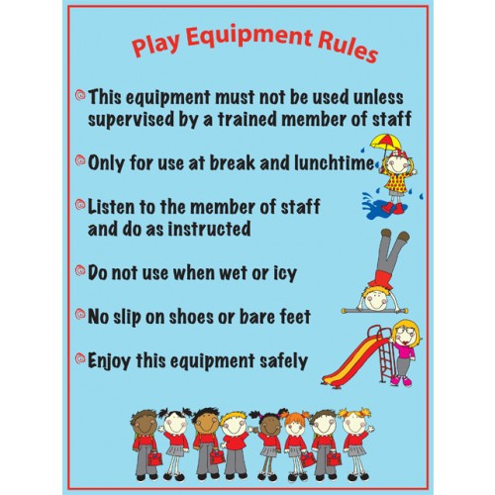

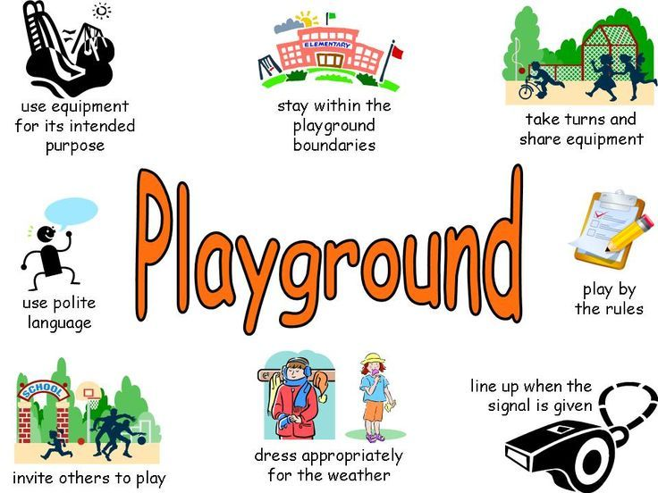

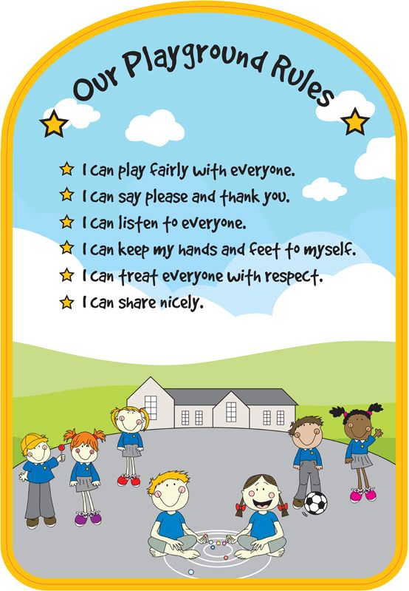

Bus Safety Polic
Bus Safety Policy

School buses are the safest way for students to travel, but children also need to do their part to stay alert and aware of their surroundings to prevent injury. KBWH urge parents to teach their children the following safety rules for getting on and off the bus, and for exercising good behavior while riding.

Getting on the Bus:
- Do not stray onto the street, alleys or private property
- Line up away from the street or road as the bus approaches
- Never try to board the bus until it has completely stopped
- Behavior on the Bus:
- If seat belts are available on the bus, buckle up
- Don’t speak loudly or make loud noises that could distract the driver
- Stay in your seat
- Don’t put your head, arms or hands out the window
- Keep aisles clear of books and bags
- Get your belongings together before reaching your stop
- Wait for the bus to stop completely before getting up from your seat
- Getting Off the Bus:
- Use the handrail when exiting
- If you have to cross in front of the bus, first walk at least 10 feet ahead until you can see the driver
- Make sure the driver can see you
- Wait for a signal from the driver before crossing
- If your vision is blocked, move to an area where you can see other drivers and they can see you
- Do not cross the center line of the road until the driver signals it is safe
- Stay away from the rear wheels of the bus at all time

APPENDIX

- Appendix 1: Recruitment Policy as set by our association
Policy
It is the Policy of Makassed to encourage career advancement from within, and it is only when no qualified candidates from inside the Association are available to fill a vacancy, that external sourcing and recruitment processes would be initiated.

Internal Recruitment
All employees are eligible to apply for internal job openings if they meet the requirements mentioned in the job posting announcement.
No employee who applies for an internal recruitment opportunity will be subject to any formal or informal measures from his/her direct supervisor, and his/her application, if not selected, will not be held against him/her by any means.
Employees who believe that they are being harassed for applying for internal recruitment should inform the HR directorate immediately and follow the course of the Grievance Procedure.

External Recruitment
In case of reference to external recruitment, it is endorsed that all applications will be treated equally and with confidentiality, and the only differentiation between applicants during the screening process is based on credentials presented by the applicant him/herself.

Procedure
In order to initiate a recruitment activity, the authorized requester should follow the following procedure. The authorized requester is the concerned department manager/ director. The recruitment activity will be launched by the HC Directorate as per the workforce planning and staffing plan.

- Whenever a vacancy arises, the authorized requester should inform the HC directorate via email of in writing justifying the need for the position.
- The HC directorate will verify the accuracy of the request and will ensure its compliance with the previously approved annual Manpower Plan.
- In cases where the request is not valid, an answer will be provided to the requester; else, the HC directorate will proceed to regular recruitment procedures.
- Type of vacancy:
  - If the vacancy is for a new position – previously none existing, the HC directorate seeks the approval of the President.
  - If the vacancy is to fill an existing vacant position, the recruitment unit initiates the recruitment procedures.

- The recruitment unit will search the existing CV’s bank for suitable candidates,
In coordination with the HC director.
  - If a prospective profile is identified, the applicant is short listed.
  - If no suitable applicant is found in the CV bank, the recruitment unit will post the vacancy on Makassed’s website, under career opportunities, with the following guidelines:

    - The job posting shall be classifies under academic, non- academic or other vacancies.
    - The posting shall state the title of the position, the basic functions and the minimum requirements.
    - The posting should specify that Makassed provides the opportunity for promotion from within, so interested qualified internal candidates should apply for an internal transfer by the specified deadline.
    - All postings should state that “within the framework of Lebanese Law, Makassed is an equal opportunity employer”.

- The recruitment application process for :

  - Internal candidates:
    - Should complete an internal transfer request and submit it to his/her direct supervisor/manager.
    - The direct supervisor/manager of the employee should sign the form stating his/her recommendation.
    - The transfer form is forwarded to the HC directorate, which evaluates the applicant’s experience and credentials against the requirements of the current vacancy. If the existing employee qualifies for the position, he/ she is shortlisted.

  - External candidates: After making sure that there are no internal candidates to fill the vacant position, the HC directorate will search among external applicants who may apply:
    - Through the Makassed’s website by checking under career opportunities and selecting the position of interest and completing the application.
    - In person, by visiting the HC directorate located in the Association’s Headquarters building.
Policy Application
This Policy applies to all recruitment procedures at Makassed, excluding the recruitment of Advisors and Consultants who are appointed directly by the President.

Related Policies
Selection, Workforce Planning, Appointment, Contracts Management Policies.

Forms
- Recruitment Request Form (Excel Sheet)
- Internal Transfer Request
- Sample of Job Description and Specification

- Appendix 2: Code of Conduct for all Staff

All staff teaching and non-teaching at KBWH must sign and abide by this Code of Conduct.
I ……………………………………. agree to:
- Never threaten students.
-Always making children my priority, listen to and respect them and give them the power and ability to participate more in things related to them.
- Use safety measures to ensure that children are safe all the time inside the school and outside during trips.
-Abide by the school’s dress code, I will always dress properly while working with children.
- Treat all children with respect, equity and dignity.
- Never hit, insult, neglect or abuse students physically or verbally.
- Always meet the students in an easily accessed unlocked room.
-Always be aware of the children’s need for personal space or extra support.
-Intervene to stop bullying in any case of violence and/or abuse among children.
- Be an advocate to my students and help them whenever possible.
- Immediately report to the counselor and/or the administration any concern related to the child protection using the approved procedures.
- Make sure that there is a written permission from the parents to share pictures on social media
-Make sure not to give private tutoring to my students.
- Refer to the nurse whenever a student shows illness symptoms or need to take medication.
And specifically will not:
- Allow or participate in games that are violent in nature.
-Allow any inappropriate touching.
-Use or allow the use of abusive words in front of or from children.
-Socialize with the students on trips or outings that are not organized by the school.
-Invite a child to my home without a specific reason and without a guardian’s written consent.
- Threaten students so that they do not report s problem to their parents or the administration.
- Discuss the academic & behavior status of students with other members of the school community unless being asked to during class councils and/or meetings held for administrative purposes.
- Take photos of students while misbehaving to shed light on their disruptive behavior.

Signature: ………………………………………………………
Date: …………………………………………………………….

- Appendix 3: KBWH Code of Conduct for preschool students

We the students of KBWH in _______, pledge to:

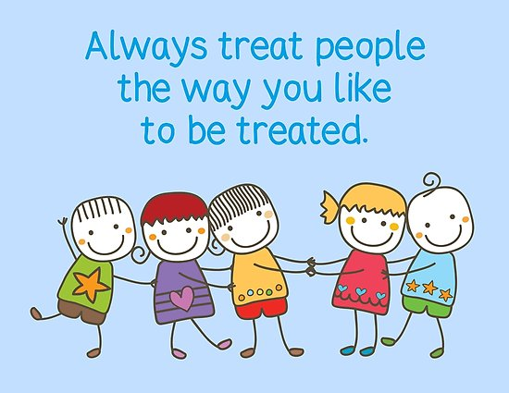
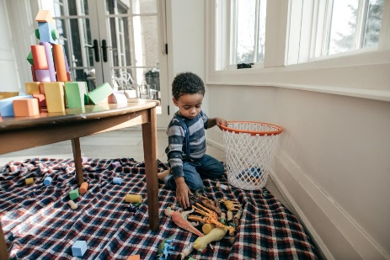

Be polite and respect others Clean up after work and play

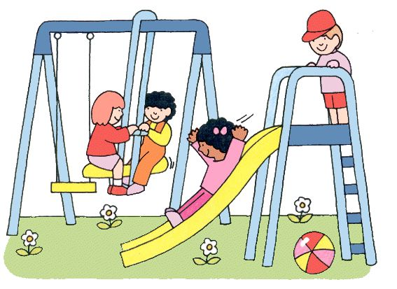

Play safely

And pledge not to:
Fight with others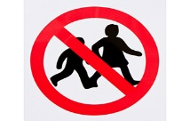

- Appendix 4: KBWH Code of Conduct for Elementary Students
We the students of KBWH in grade ______, pledge to:
- Play safely, be gentle, and respect others.
- Respect the staff and other adults.
- Be polite.
- Share and play together.
- Clean up after work and play.
And we pledge not to:
- Fight with others.
- Use impolite words.
- Run, shout, or scream.
……………………………………………………………………………………
Signatures of all the students:

Name and signature of the class advisor: ___________________________
Date: ______________________________

- Appendix 5: KBWH Code of Conduct for Middle & Secondary Students

We the students of KBWH in grade ___________, pledge to:
- Respect the rights and interests of other students, teachers, staff, and visitors and consider others’ feelings
- Be kind to other students and avoid discrimination or disturbance against them
- Behave properly on school campus, in classrooms, on school busses, and in all kinds of school activities by following the rules and policies at school
- Take care of school properties and maintain the cleanliness of school campus

And we pledge not to:
- Bully others
- Use vulgar or bad words
- Hurt others feelings in any mean
……………………………………………………………………………………
Signatures of all the students:

Name and signature of the class advisor: ___________________________
Date: _____________________________

- Appendix 6: Students’ Family Issues

Students’ Family Issues
رصد حالات عائلية للتلاميذ
Preschool Cycle 1 Cycle 2 Cycle 3 Cycle 4
Student Name  إسم التلميذ(ة) | Grade  الصف | طلاق الوالدين  Parents’ Divorce | انفصال الوالدين  Parents’ separation | مشاكل عائلية  Family Problems | وفاة الوالد  Death of father | وفاة الوالدة  Death of mother | وفاة أحد الأخوة  Death of sister(s) or brother(s) | مرض أحد أفراد العائلة  Illness of family member(s) | حالات أخرى  Others

- Appendix 7: Students’ Behavior Record:

Students’ Behavior Record
رصد حالات سلوكية للتلاميذ
Preschool Cycle 1 Cycle 2 Cycle 3 Cycle 4
Term one Term two Term Three
Student Name  إسم التلميذ(ة) | Grade + Section  الصف و الشعبة | Teachers’ Names  أسماء المعلمات | Date  التاريخ | During  (Class – Recess)  خلال حصة دراسية – فرصة ..... | Behavior description  وصف السلوك | Action Taken  الإجراءات

- Appendix 8: School Safety Inspection Checklist

School Safety
Inspection Checklist
قائمة تدقيق للسلامة المدرسية

التاريخ/Date: _____________ الفصل/ Term: _________ القسمSector/ : ___________

الطابق/Floor: _______ اسم المدقق/ Inspector’s name: ____________________
Requirements  المتطلبات | Yes  نعم | No  لا | Follow up  خطة المتابعة
1.Asiles and doorways are free of materials or equipment
الممرات والمداخل خالية من المواد و المعدات
2. Floors are clean and well-maintained and free from cracks, holes, dips, etc…
الأرضيات نظيفة وصيانتها جيدة وخالية من الشقوق والثقوب والانخفاضات وما إلى ذلك.
3. Soap and towel are present in washrooms
المحارم و الصابون موجود في الحمامات
Desks, chairs, and shelves are clear of rubbish
المكاتب والكراسي والرفوف خالية من العواقب كالمسامير وما الى ذلك.
4. Doors and shelves are in good condition
الرفوف والأبواب بحالة جيدة
5. Signs and bulletins are securely fastened to the wall.
اللوحات الجدارية ثابتة بشكل آمن على الحائط.
6. Electrical cords are secured under desks or along baseboards
الأسلاك الكهربائية موضوعة تحت المكاتب أو داخل علب مخصصة.
7. Plugs and switches are in good condition.
المقابس والمفاتيح الكهربائية في حالة جيدة و آمنة.
8. The light bulbs are in good condition
المصابيح الكهربائية في حالة جيدة
9. Electrical fans are well maintained and out of students’ reach.
المراوح الكهربائية تعمل بشكل جيد وبعيدًا عن متناول التلاميذ.
10.Windows are secured and safe
النوافذ مؤمنة وآمنة

